**PRACTICAL 2**

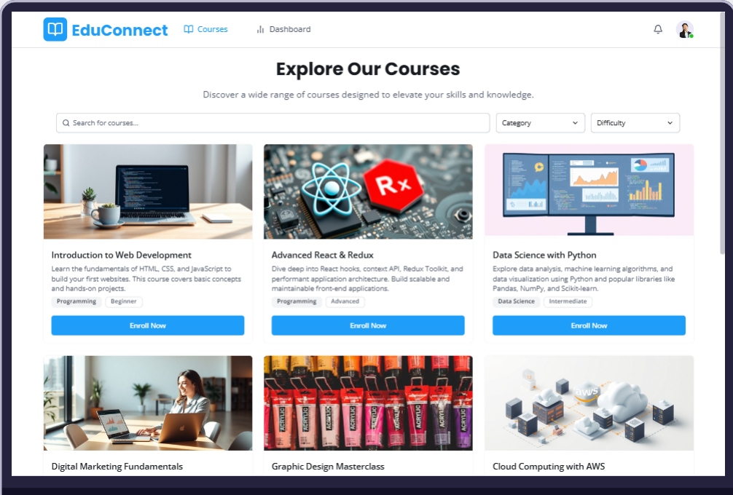

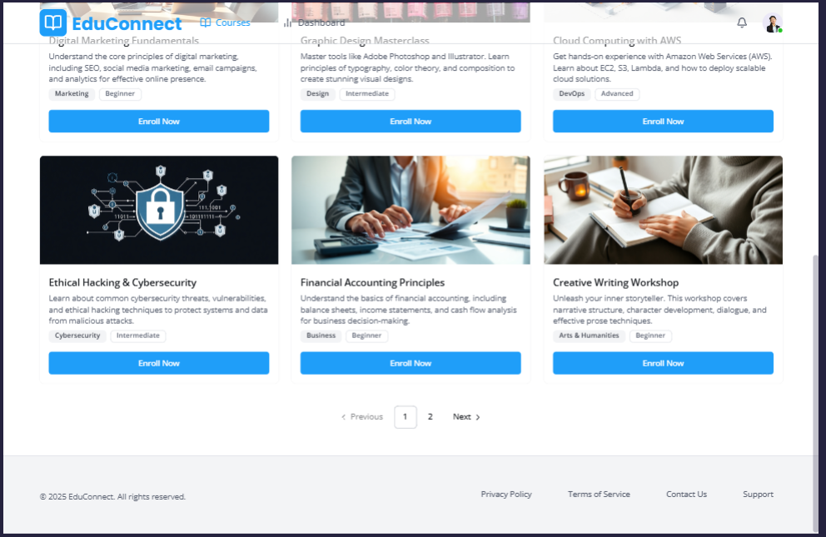

**Fig 2.1 Course Listings**

**Fig 2.2** **Course Listings**

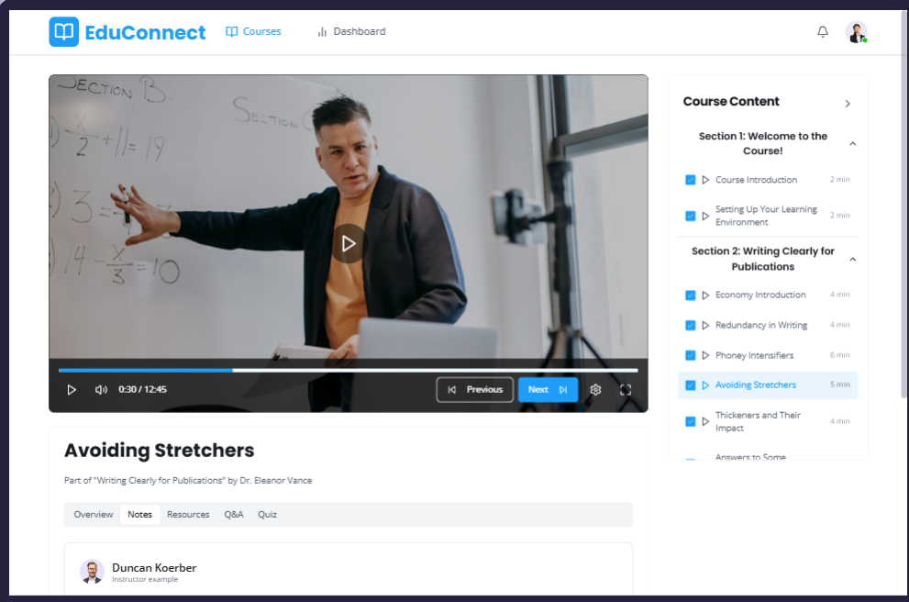

**Fig 2.3** **Lecture Player**

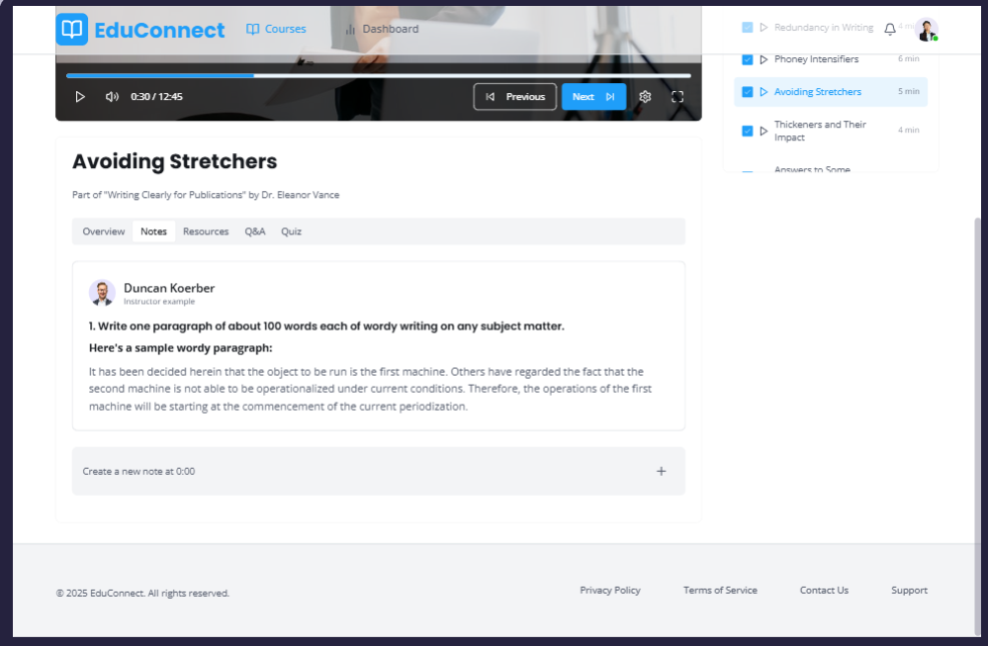

**Fig 2.4** **Lecture Player**

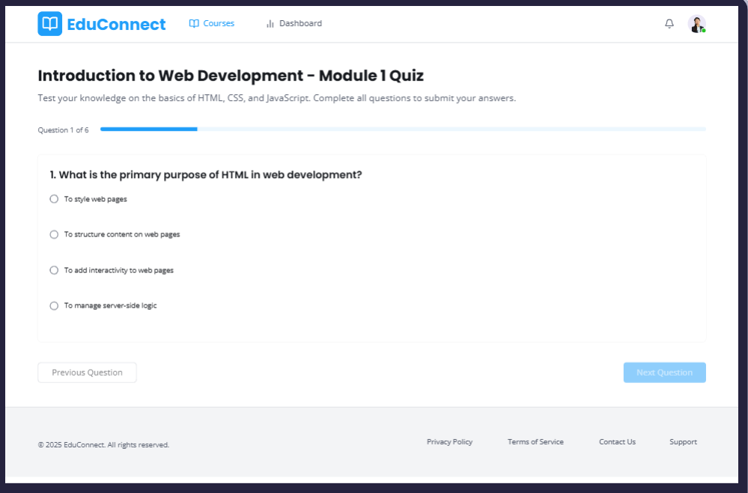

**Fig 2.5 Quiz Interface**

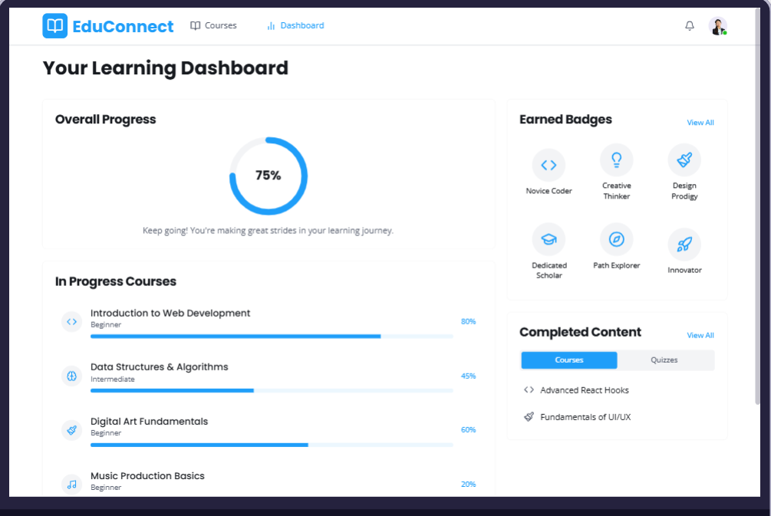

**Fig 2.6 Progress Dashboard**

**PRACTICAL 3**

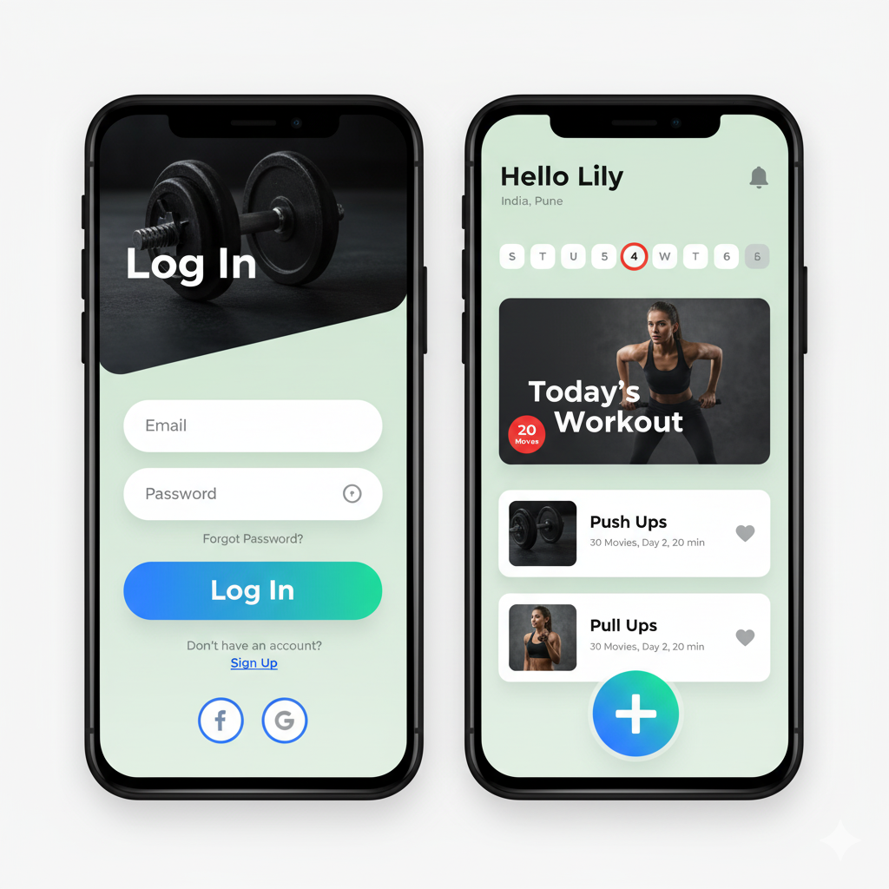

**Fig 3.1 Login Screen and Home Screen**

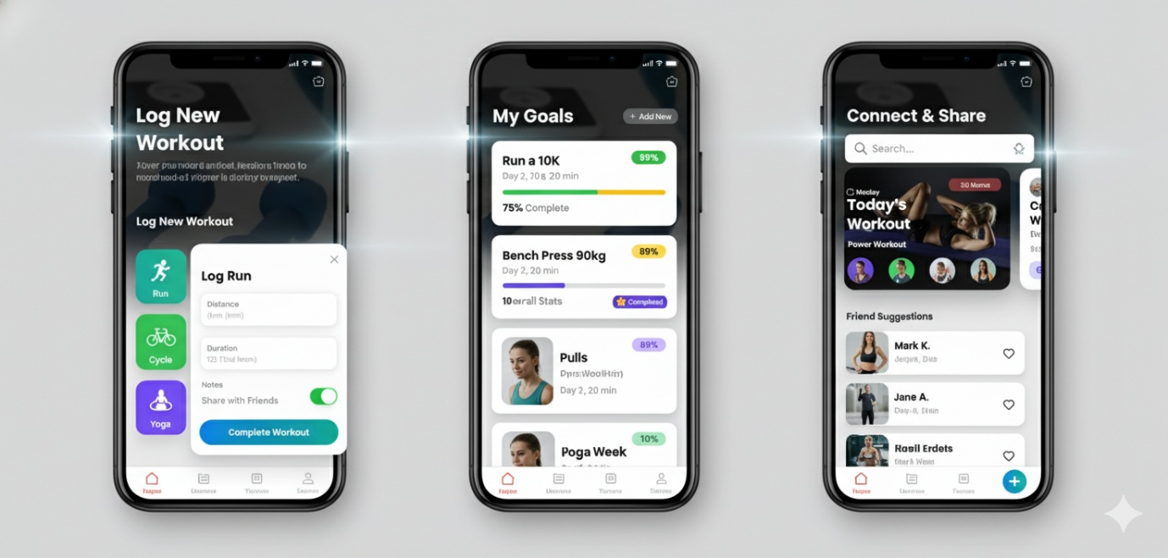

**Fig 3.2 Goals and connect**

**PRACTICAL 4**

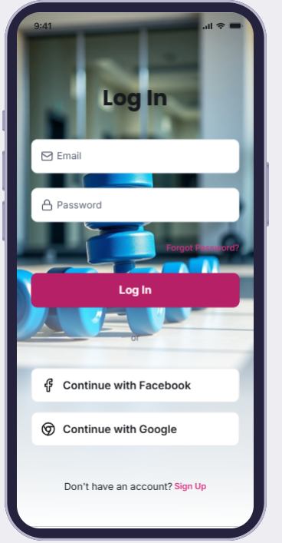

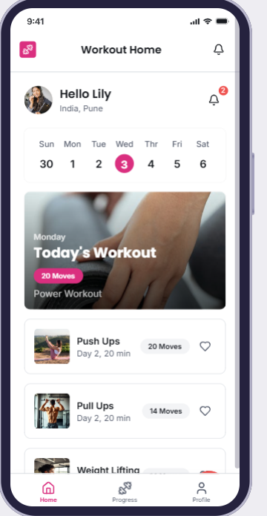

**Fig 4.2 Home**

**Fig 4.1 Login**

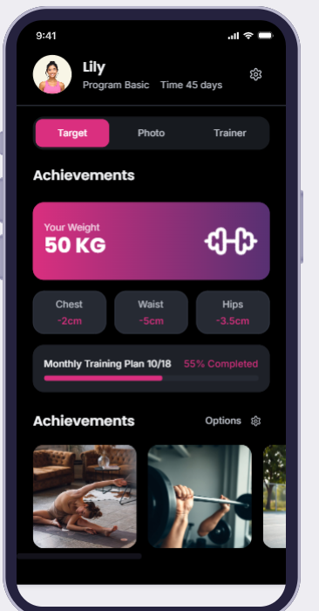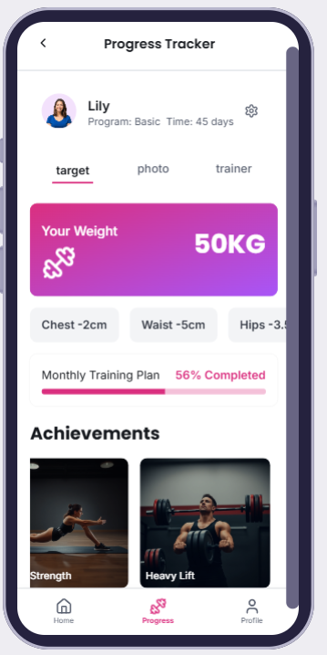

**Fig 4.4 Dashboard**

**Fig 4.3 Progress**

**PRACTICAL 5**

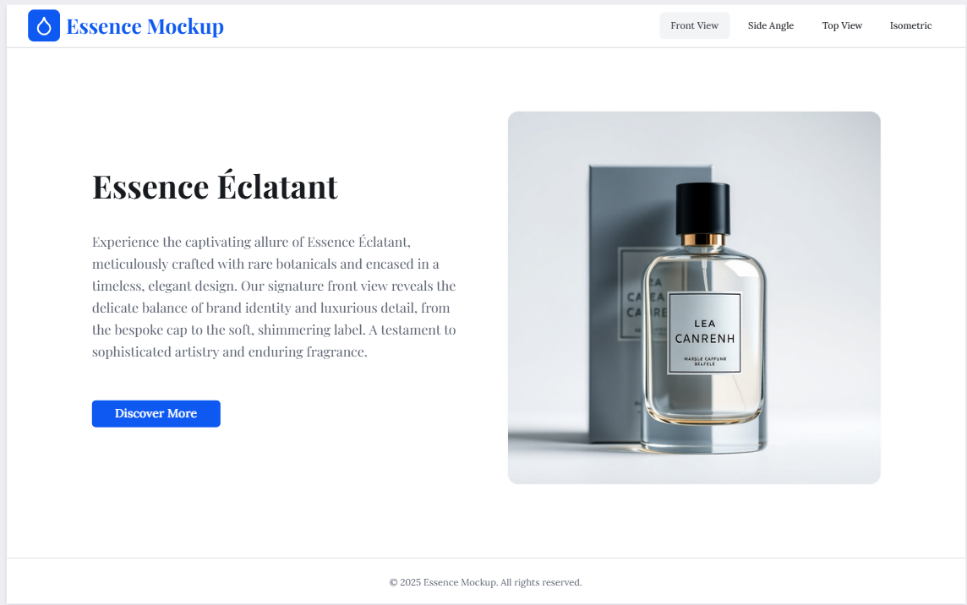

**Fig 5.1 Product Mockup Front View**

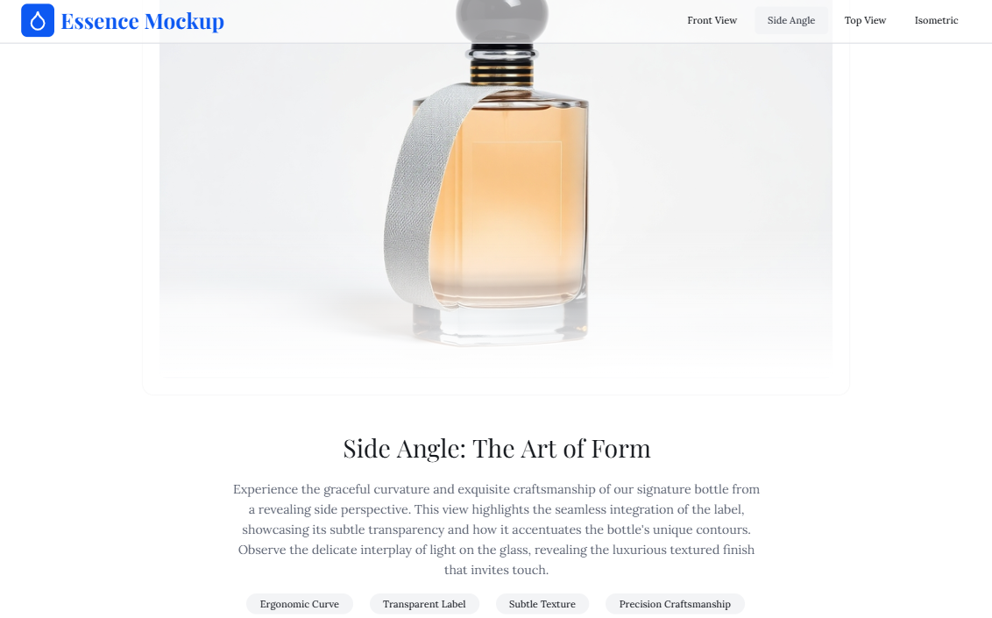

**Fig 5.2 Product Mockup Side View**

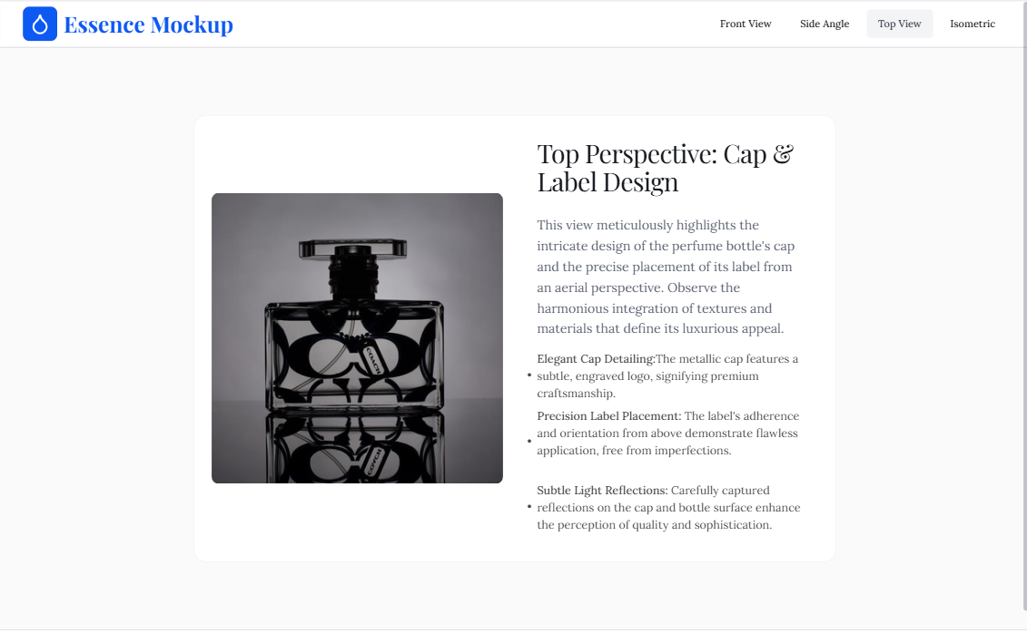

**Fig 5.3 Product Mockup Top View**



**Fig 5.4 Product Mockup Isometric View**

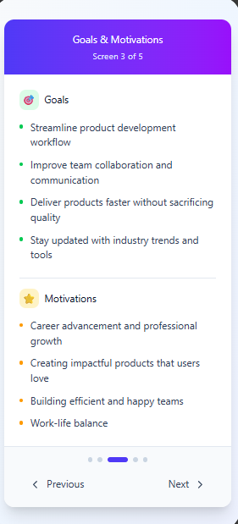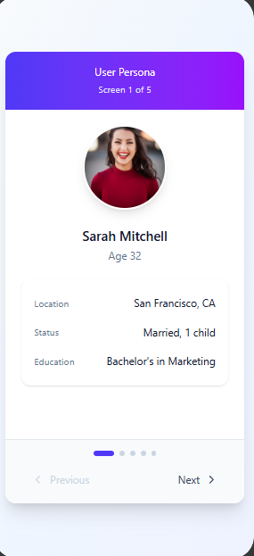**PRACTICAL 1**

